Linear Arrangement

Definition
# Source: AI Source: Provided by: [Data Path: Persons Table -> ID Column: 1, Name_En Column: Motasem Essam] -> From: [ChatGPT] on [7/25/2026]
Linear Arrangement is a type of composite solid arrangement in which two or more repeated solid components are positioned consecutively along a common straight line or axis.
The components may be identical in shape and dimensions, or they may have different dimensions while belonging to the same geometric family. They are arranged one after another, either through direct contact or with spaces between them, depending on the intended configuration.
When the components are joined, their contact regions become hidden internal interfaces.

Simple Definition
# Source: AI Source: Provided by: [Data Path: Persons Table -> ID Column: 1, Name_En Column: Motasem Essam] -> From: [ChatGPT] on [7/25/2026]
A composite solid formed by arranging repeated solid components one after another along a straight line.

Geometric Representation
# Source: AI Source: Provided by: [Data Path: Persons Table -> ID Column: 1, Name_En Column: Motasem Essam] -> From: [ChatGPT] on [7/25/2026]
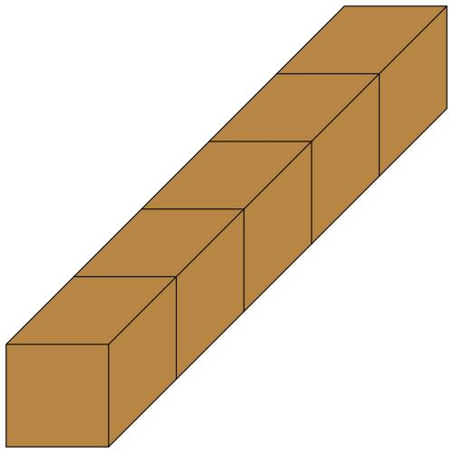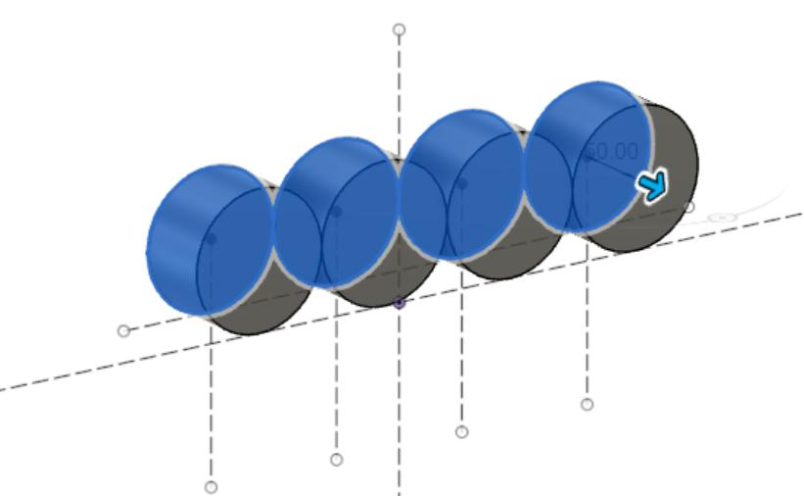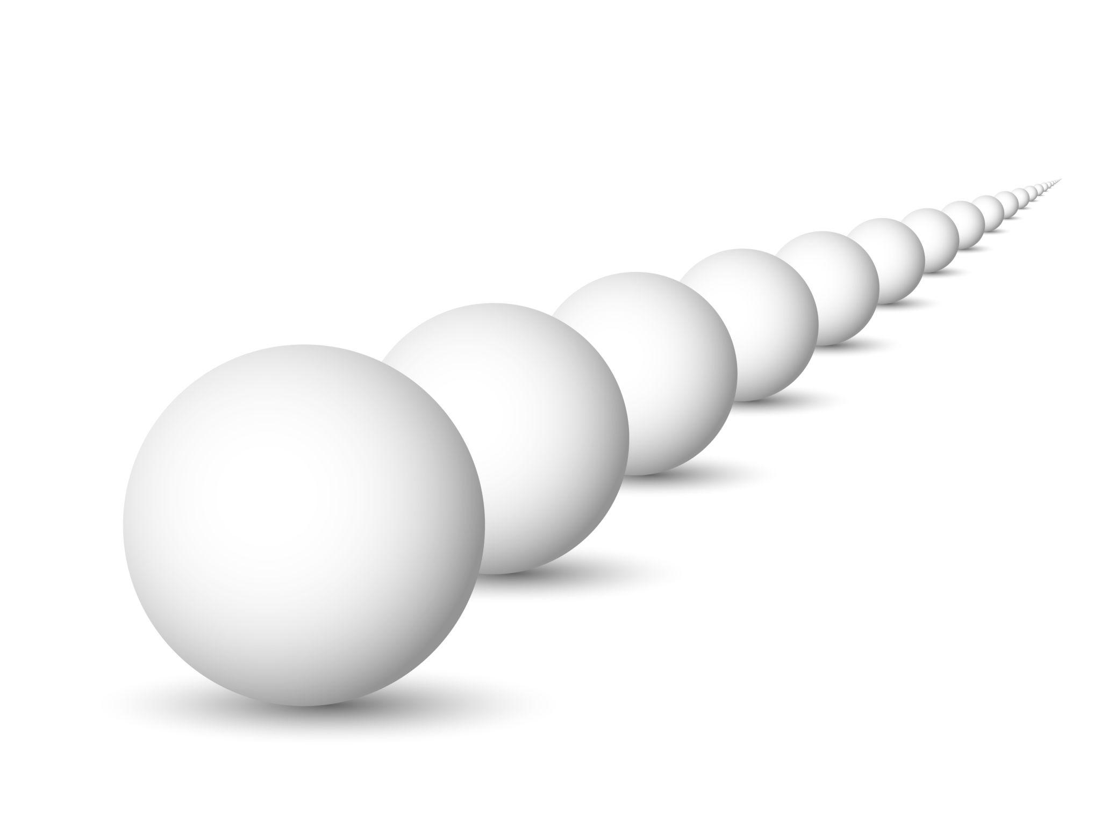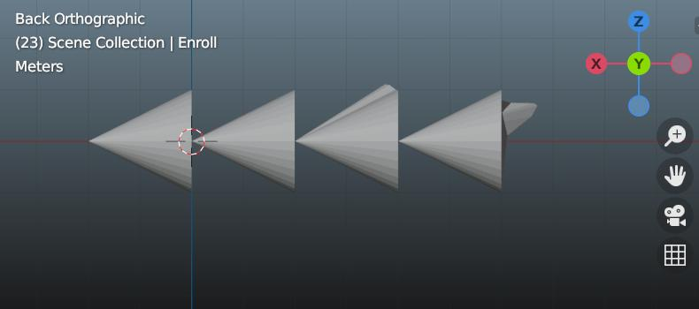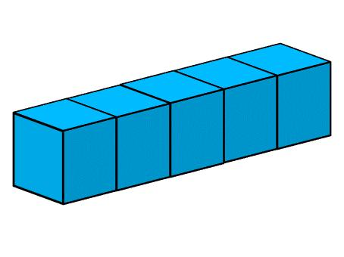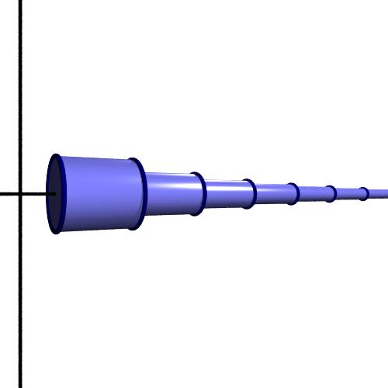
A linear arrangement has three important characteristics:
- Common direction: Components follow the same straight-line direction.
- Sequential positioning: Each component follows the preceding component.
- Repeated components: The same solid shape or a repeated geometric family is used.

Main Classification
# Source: AI Source: Provided by: [Data Path: Persons Table -> ID Column: 1, Name_En Column: Motasem Essam] -> From: [ChatGPT] on [7/25/2026]
Linear arrangements can be classified according to the geometric shape of their repeated components.

Cube-Based Linear Arrangement
# Source: AI Source: Provided by: [Data Path: Persons Table -> ID Column: 1, Name_En Column: Motasem Essam] -> From: [ChatGPT] on [7/25/2026]
A composite solid formed by arranging two or more cubes consecutively along a straight line.
Characteristics:
- All components are cubes.
- Components may have equal or different side lengths.
- When equal cubes are joined face-to-face, they form a rectangular prism.

Rectangular Prism-Based Linear Arrangement
# Source: AI Source: Provided by: [Data Path: Persons Table -> ID Column: 1, Name_En Column: Motasem Essam] -> From: [ChatGPT] on [7/25/2026]
A composite solid formed by arranging repeated rectangular prisms consecutively along a common direction.
Characteristics:
- Components have rectangular prism shapes.
- Their dimensions may be identical or different.
- They may form an elongated rectangular structure.
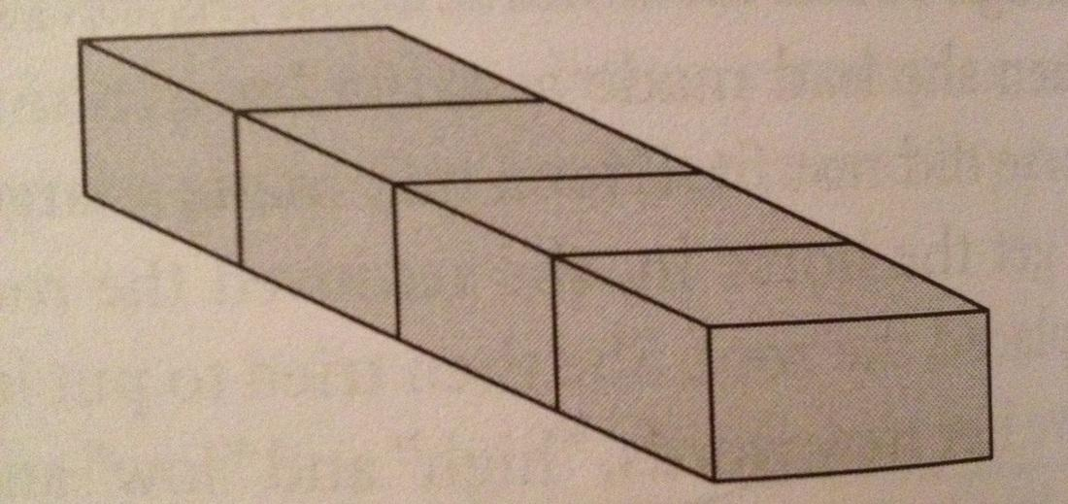

Cylinder-Based Linear Arrangement
# Source: AI Source: Provided by: [Data Path: Persons Table -> ID Column: 1, Name_En Column: Motasem Essam] -> From: [ChatGPT] on [7/25/2026]
A composite solid formed by arranging two or more cylinders consecutively along a common central axis.
Characteristics:
- Cylinders are positioned along a common axis.
- They may have equal or different radii and heights.
- Their circular bases may form the joining interfaces.
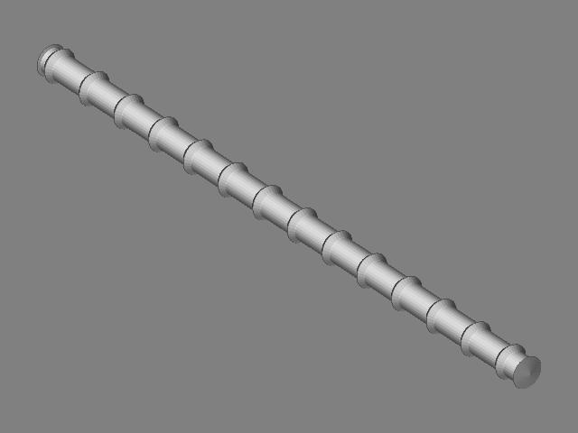

Cone-Based Linear Arrangement
# Source: AI Source: Provided by: [Data Path: Persons Table -> ID Column: 1, Name_En Column: Motasem Essam] -> From: [ChatGPT] on [7/25/2026]
A composite solid formed by arranging repeated cones consecutively along a common straight-line direction.
Possible configurations include:
- Cones joined base-to-base.
- Cones joined through other matching or partial contact regions.
- Cones arranged with their axes aligned.

Sphere-Based Linear Arrangement
# Source: AI Source: Provided by: [Data Path: Persons Table -> ID Column: 1, Name_En Column: Motasem Essam] -> From: [ChatGPT] on [7/25/2026]
A composite arrangement in which two or more spheres are positioned consecutively along a straight line.
Characteristics:
- Sphere centers lie along a common straight line.
- Spheres may have equal or different radii.
- Separate spheres may touch at points or remain spaced apart.
Important: Spheres that touch externally at individual points do not form a single connected solid with a positive-area joining interface. They are a linear arrangement of components, but point contact does not hide a finite surface area.

Hemisphere-Based Linear Arrangement
# Source: AI Source: Provided by: [Data Path: Persons Table -> ID Column: 1, Name_En Column: Motasem Essam] -> From: [ChatGPT] on [7/25/2026]
A composite solid arrangement formed by positioning two or more hemispheres consecutively along a straight-line direction.
Possible configurations include:
- Hemispheres joined through their flat circular bases.
- Hemispheres arranged with their curved surfaces facing in alternating directions.
- Repeated hemispherical components connected through other solid components.
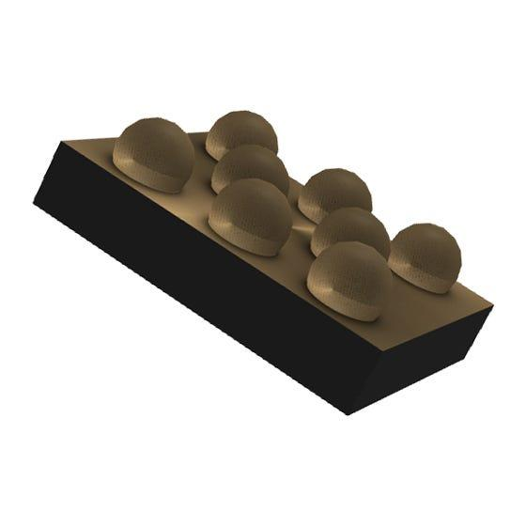

Mixed-Shape Linear Arrangement
# Source: AI Source: Provided by: [Data Path: Persons Table -> ID Column: 1, Name_En Column: Motasem Essam] -> From: [ChatGPT] on [7/25/2026]
A linear arrangement containing repeated components from two or more different geometric solid types, positioned consecutively along a common straight-line direction.
Examples:
- Alternating cylinders and cones.
- Cylinders connected to hemispherical components.
- Repeated sequences of prisms, cylinders, and cones.
- A sequence of different solid types with a repeated pattern.
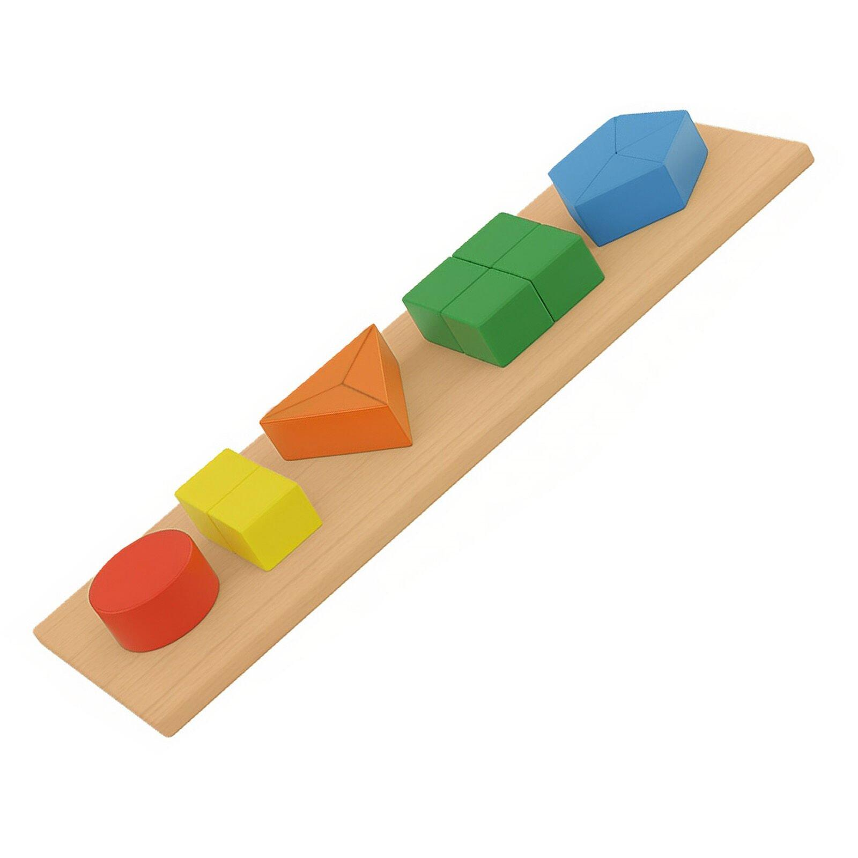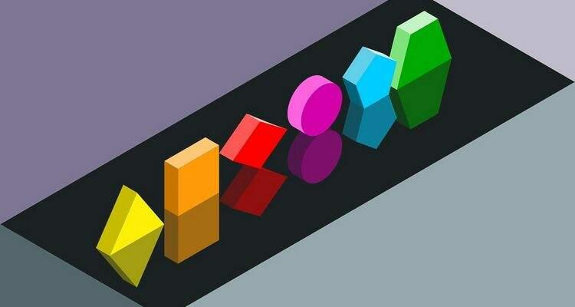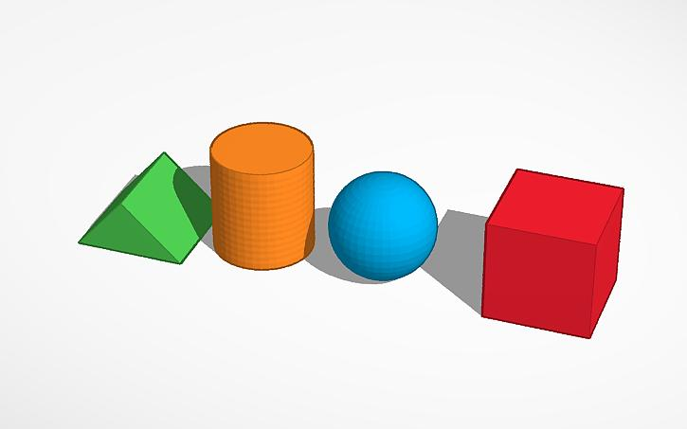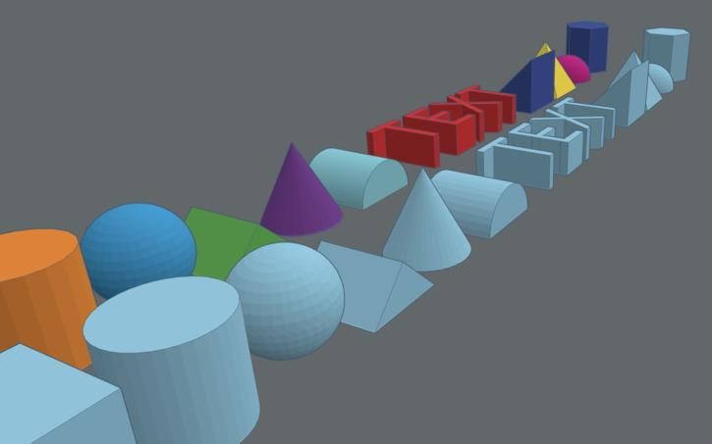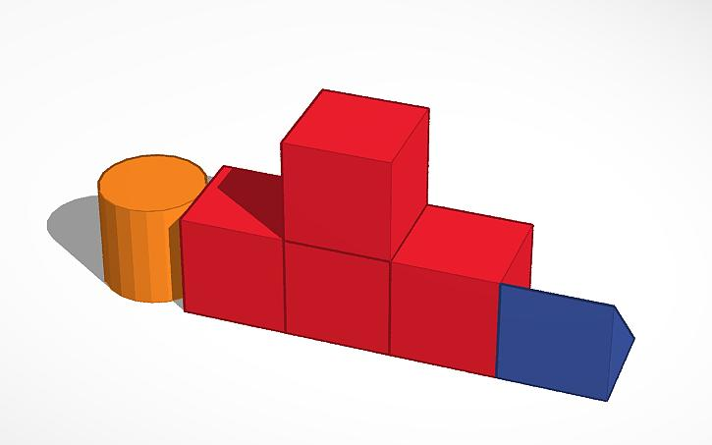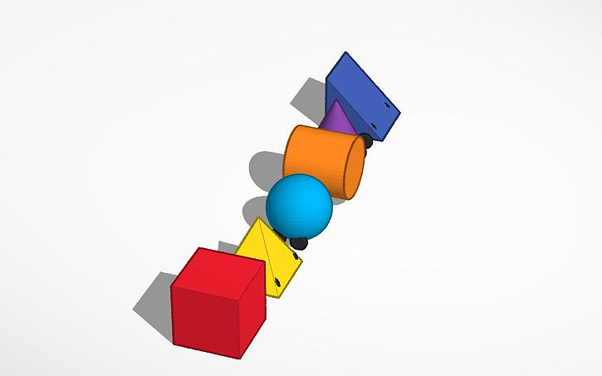

Classification by Component Contact
# Source: AI Source: Provided by: [Data Path: Persons Table -> ID Column: 1, Name_En Column: Motasem Essam] -> From: [ChatGPT] on [7/25/2026]
Linear arrangements can also be classified according to how consecutive components are positioned relative to each other.

Directly Joined Linear Arrangement
# Source: AI Source: Provided by: [Data Path: Persons Table -> ID Column: 1, Name_En Column: Motasem Essam] -> From: [ChatGPT] on [7/25/2026]
Components are connected directly through a shared contact region.
Examples:
- Cubes joined face-to-face.
- Cylinders joined through circular bases.
- Hemispheres joined through flat circular bases.

Spaced Linear Arrangement
# Source: AI Source: Provided by: [Data Path: Persons Table -> ID Column: 1, Name_En Column: Motasem Essam] -> From: [ChatGPT] on [7/25/2026]
Components are positioned along the same straight line but have gaps between consecutive components.
Examples:
- Separate spheres arranged along a line.
- Cylinders separated by equal gaps.
- Repeated cubes positioned at regular intervals.


Partially Joined Linear Arrangement
# Source: AI Source: Provided by: [Data Path: Persons Table -> ID Column: 1, Name_En Column: Motasem Essam] -> From: [ChatGPT] on [7/25/2026]
Consecutive components touch through only part of their possible contact regions.
Examples:
- A smaller cylinder joined to a larger cylinder through a smaller circular region.
- A cone attached to a prism through a circular portion of a polygonal face.
- Components joined through partial planar contact.
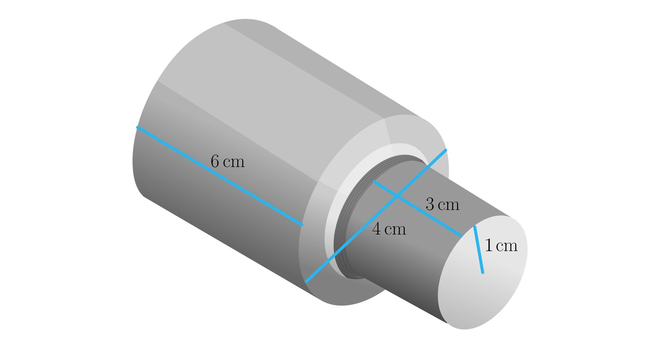

Classification by Component Dimensions
# Source: AI Source: Provided by: [Data Path: Persons Table -> ID Column: 1, Name_En Column: Motasem Essam] -> From: [ChatGPT] on [7/25/2026]
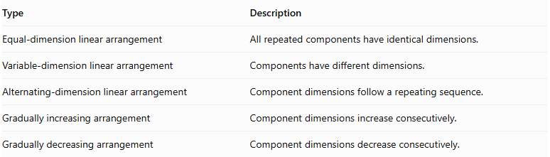
Type | Description
Equal-dimension linear arrangement | All repeated components have identical dimensions.
Variable-dimension linear arrangement | Components have different dimensions.
Alternating-dimension linear arrangement | Component dimensions follow a repeating sequence.
Gradually increasing arrangement | Component dimensions increase consecutively.
Gradually decreasing arrangement | Component dimensions decrease consecutively.
For example, a sequence of cylinders may have progressively increasing radii while their central axes remain aligned.
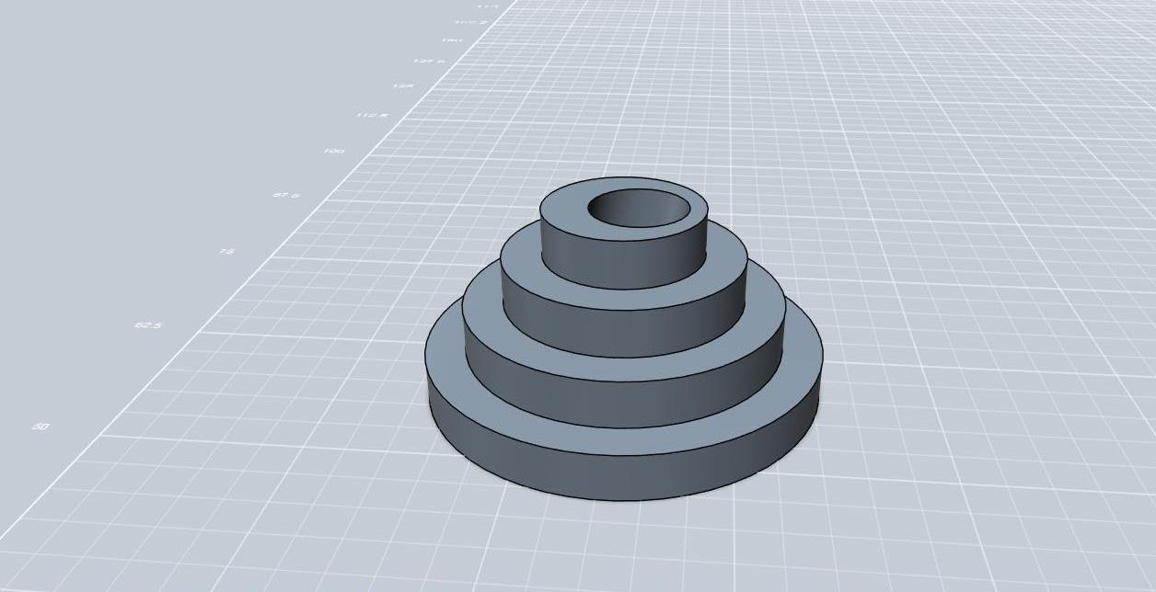

Mathematical Properties and Formulas

Total Volume
# Source: AI Source: Provided by: [Data Path: Persons Table -> ID Column: 1, Name_En Column: Motasem Essam] -> From: [ChatGPT] on [7/25/2026]
For $n$ components arranged without overlapping interiors:
$$V_{total}=\sum_{i=1}^{n}{V_{i}}$$
For identical components:
$$\boxed{V_{total}={nV}_{component}}$$
Common examples:
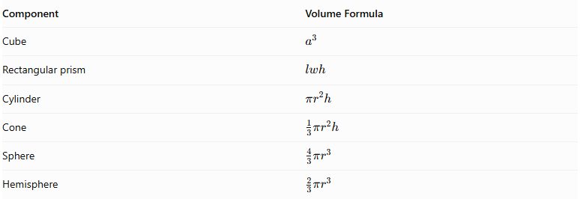
Component | Volume Formula
Cube | $$a^{3}$$
Rectangular prism | $$lwh$$
Cylinder | $$πr^{2}h$$
Cone | $$\frac{1}{3}πr^{2}h$$
Sphere | $$\frac{4}{3}πr^{3}$$
Hemisphere | $$\frac{2}{3}πr^{3}$$

Overall Length
# Source: AI Source: Provided by: [Data Path: Persons Table -> ID Column: 1, Name_En Column: Motasem Essam] -> From: [ChatGPT] on [7/25/2026]
When components are arranged consecutively along a common direction without gaps or overlaps:
$$\boxed{L_{total}=\sum_{i=1}^{n}{L_{i}}}$$
For identical components:
$$\boxed{L_{total}=nL}$$
If equal gaps of length $g$ separate the components:
$$L_{total}=nL+(n-1)g$$
Here, $n$ is the number of components and $L$ is the length of each component along the arrangement direction.

External Surface Area
# Source: AI Source: Provided by: [Data Path: Persons Table -> ID Column: 1, Name_En Column: Motasem Essam] -> From: [ChatGPT] on [7/25/2026]
For directly joined components:
$${SA}_{external}=\sum{{SA}_{individual}}-\sum{A_{hidden interfaces}}$$
For complete matching planar joining faces:
$$\boxed{{SA}_{external}=\sum{{SA}_{individual}}-2\sum{A_{joining}}}$$
For components that touch only at points, such as externally tangent spheres, the contact area is zero.
For spaced components, no joining interfaces are hidden, so the total exposed area is the sum of their individual surface areas.

Worked Examples

Example 1: Linear Arrangement of Identical Cubes
# Source: AI Source: Provided by: [Data Path: Persons Table -> ID Column: 1, Name_En Column: Motasem Essam] -> From: [ChatGPT] on [7/25/2026]
Five identical cubes, each with a side length of $4 cm$, are joined face-to-face in a straight line.
Step 1: Calculate the volume of one cube.
$$V_{1}=a^{3}$$
$$V_{1}=4^{3}=64{ cm}^{3}$$
Step 2: Calculate the total volume.
$$V_{total}=5×64$$
$$\boxed{V_{total}=320{ cm}^{3}}$$
Step 3: Calculate the overall length.
$$L_{total}=5×4$$
$$\boxed{L_{total}=20 cm}$$
Step 4: Calculate the external surface area.
The five cubes form a rectangular prism with dimensions:
$$20×4×4$$
$$SA=2(lw+lh+wh)$$
$$=2(20×4+20×4+4×4)$$
$$=2(80+80+16)$$
$$\boxed{SA=352{ cm}^{2}}$$

Example 2: Linear Arrangement of Three Cylinders
# Source: AI Source: Provided by: [Data Path: Persons Table -> ID Column: 1, Name_En Column: Motasem Essam] -> From: [ChatGPT] on [7/25/2026]
Three cylinders are joined end-to-end along a common central axis.
Their dimensions are:
- Cylinder 1: $r=2 cm, h=4 cm$.
- Cylinder 2: $r=2 cm, h=3 cm$.
- Cylinder 3: $r=2 cm, h=5 cm$.
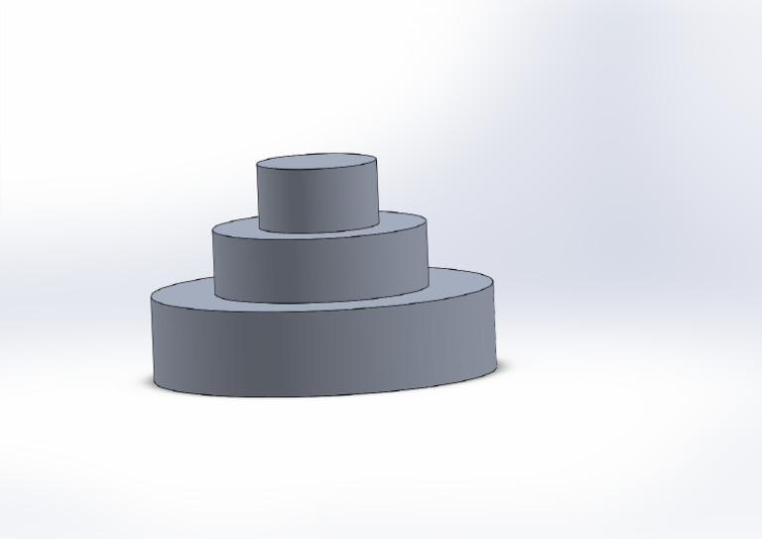
Step 1: Calculate the total volume.
$$V=πr^{2}(h_{1}+h_{2}+h_{3})$$
$$=π(2)^{2}(4+3+5)$$
$$=4π(12)$$
$$\boxed{V=48π≈150.80{ cm}^{3}}$$
Step 2: Calculate the total length.
$$L=4+3+5$$
$$\boxed{L=12 cm}$$
Step 3: Calculate the external surface area.
The two joining circular interfaces are hidden. The external surface consists of:
- The total curved lateral surface.
- The two circular end faces.
$$SA=2πrL+2πr^{2}$$
$$=2π(2)(12)+2π(2)^{2}$$
$$=48π+8π$$
$$\boxed{SA=56π≈175.93{ cm}^{2}}$$

Important Characteristics
# Source: AI Source: Provided by: [Data Path: Persons Table -> ID Column: 1, Name_En Column: Motasem Essam] -> From: [ChatGPT] on [7/25/2026]
- Straight-line positioning: Components follow a common straight direction.
- Sequential arrangement: Components are positioned one after another.
- Repeated components: The arrangement contains repeated solid components or a repeating pattern of solid types.
- Variable dimensions: Components may have identical or different dimensions.
- Common alignment: Components may share a common axis or direction.
- Flexible contact: Components may be joined directly, partially joined, or separated by gaps.
- Expandable structure: Additional components can be added while preserving the linear arrangement.
- Surface-area dependency: The external surface area depends on which component surfaces are exposed or hidden.

Comparison with Other Component Arrangements
# Source: AI Source: Provided by: [Data Path: Persons Table -> ID Column: 1, Name_En Column: Motasem Essam] -> From: [ChatGPT] on [7/25/2026]
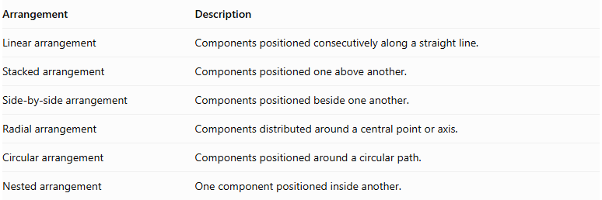
Arrangement | Description
Linear arrangement | Components positioned consecutively along a straight line.
Stacked arrangement | Components positioned one above another.
Side-by-side arrangement | Components positioned beside one another.
Radial arrangement | Components distributed around a central point or axis.
Circular arrangement | Components positioned around a circular path.
Nested arrangement | One component positioned inside another.

Applications
# Source: AI Source: Provided by: [Data Path: Persons Table -> ID Column: 1, Name_En Column: Motasem Essam] -> From: [ChatGPT] on [7/25/2026]
- Mechanical shafts made from connected cylindrical sections.
- Repeated structural blocks and construction elements.
- Pipelines formed from connected cylindrical components.
- Decorative structures made from repeated geometric shapes.
- Modular engineering assemblies.
- Industrial rollers and connected cylindrical parts.

Key Points
# Source: AI Source: Provided by: [Data Path: Persons Table -> ID Column: 1, Name_En Column: Motasem Essam] -> From: [ChatGPT] on [7/25/2026]
- Linear arrangement places repeated solid components along a common straight-line direction.
- Components can be identical or have different dimensions.
- They can be directly joined, partially joined, or separated by gaps.
- Cube-based, rectangular prism-based, cylinder-based, cone-based, sphere-based, hemisphere-based, and mixed-shape arrangements are possible.
- Total volume is the sum of component volumes when there is no overlap.
- Overall length is the sum of component lengths and any gaps.
- External surface area excludes hidden joining regions.

Conclusion
# Source: AI Source: Provided by: [Data Path: Persons Table -> ID Column: 1, Name_En Column: Motasem Essam] -> From: [ChatGPT] on [7/25/2026]
Linear Arrangement is a classification of composite solids with repeated components positioned consecutively along a common straight-line direction. It applies to arrangements of identical solids as well as sequences containing different dimensions or repeating combinations of shapes. Its geometry is determined by component dimensions, alignment, spacing, and contact regions.

